Angry Ball Documentation

Shaun McAlister & Marin Babanov

Target Device and Audience

* The game is intended to be played by two players. It is coded and optimized to be played on a computer with keyboard in order to control the characters and a mouse to navigate through the menu.
* The resolution of the assets can go maximum up to 1920x1080 (16:9) ratio which is the most common resolution for desktop monitor.
* The target audience would be young children who would play with friends or parents.

Control Methods and Game Mechanics

* Core mechanics for the game
  + Running left and right:
    - Player 1 Keyboard Controls
      * Left – “A”
      * Right – “D”
    - Player 2 Keyboard Controls
      * Left – “Left Arrow Key”
      * Right – “Right Arrow Key”
  + Jumping
    - Player 1 Keyboard Controls
      * “W”
    - Player 2 Keyboard Controls
      * “Up”
  + Shooting
    - Player 1 Keyboard Controls
      * “W”
    - Player 2 Keyboard Controls
      * “Up”
  + Life system
    - If Player 1 Loses all 5 lifes Player 2 wins
    - If Player 2 Loses all 5 lifes Player 1 wins
  + Menu Navigation
    - Mouse operation
      * Exit
      * Pause
      * Play
      * Retry

Game Objective

* The objective of the game is to use the keyboard controls to navigate the character around the fighting arena and survive. Whoever loses all 3 lifes loses the fight. The players have 3 different fighting arenas to choose from, desert, city and arctic theme. Each theme has the platforms set up differently providing diversity in gameplay.

Game Screens

* Arctic/City/Desert Maps

Map menu selection

Art Assets

* The artworks for the assets are very consistent following minimalistic shapes that form the landscape with a rough texture overlay on top. The assets are split into few categories:
  + Backgrounds:

Main Menu/ Pause Menu

Artwork for the City Arena Background

Artwork for the City Desert Background



Artwork for the Arctic Arena Background

* + Platforms:

City Platform. The asset is then stacked next to each other in order to create longer platfroms.

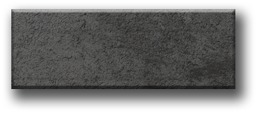

Arctic Platform. The asset is then stacked next to each other in order to create longer platfroms.

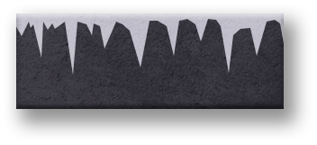

Desert Platform. The asset is then stacked next to each other in order to create longer platfroms.

* + Characters & UI:

Player 1 asset

Player 2 asset

Bullet asset

Life assets for Player 1 and Player 2

Logo

* + Icons:

Exit Icons – Static / Hover / On Click

Pause Icons – Static / Hover / On Click



Play Icons – Static / Hover / On Click



Retry Icons – Static / Hover / On Click

Gameplay Outlines

* Main Menu

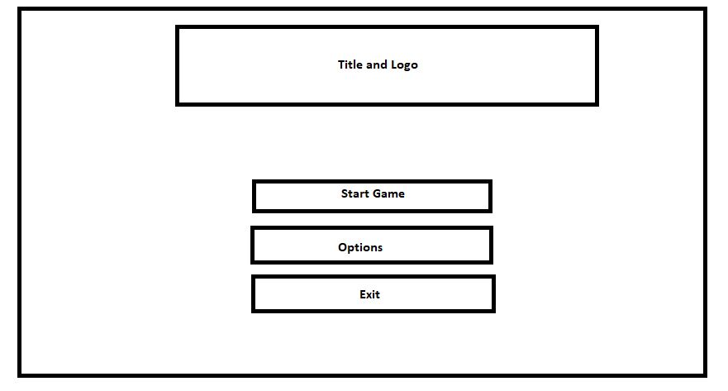

* Map Selection

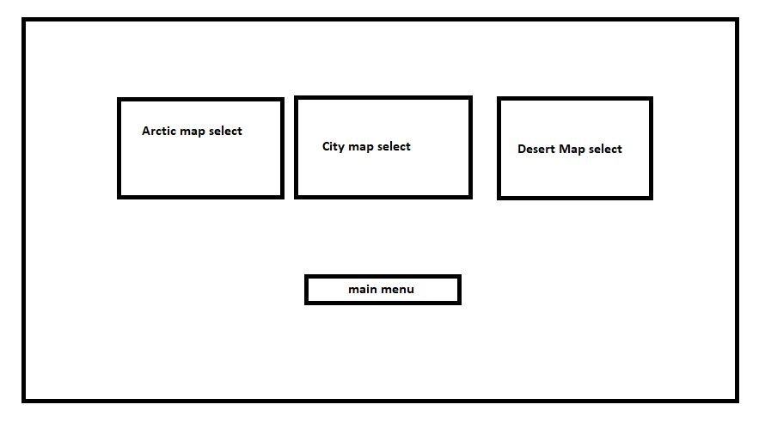

* Playing screen

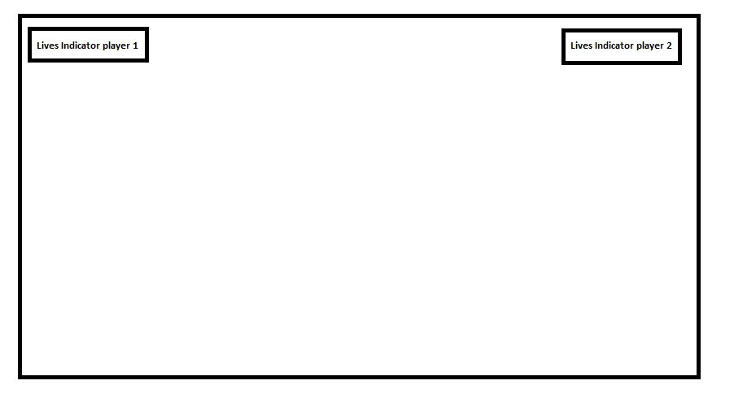

* Winner Screen

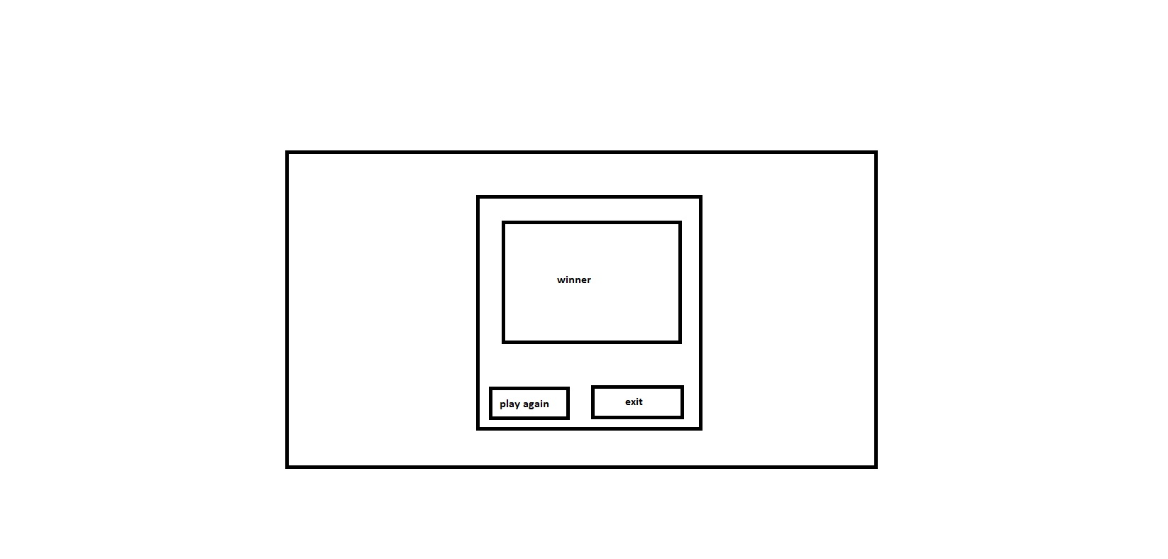

Pause Menu

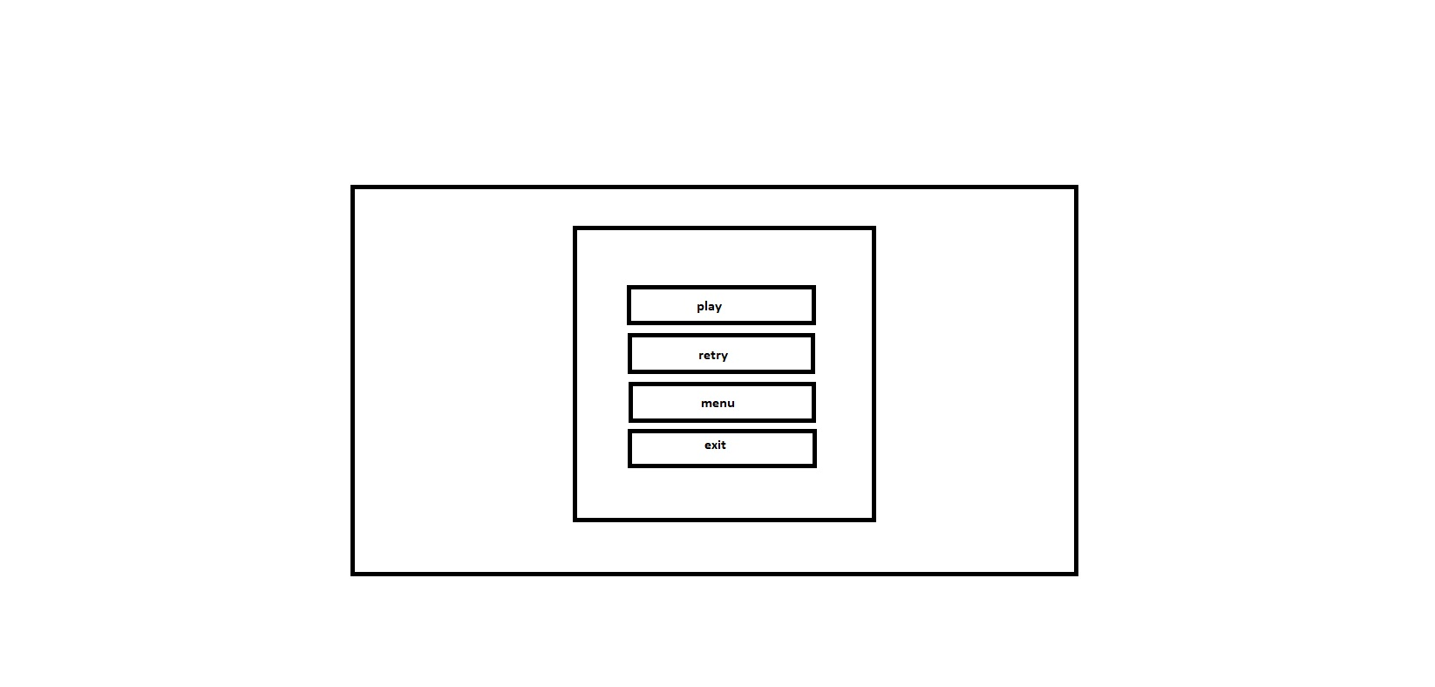

Sketches

